MEALS FOR
MAY JUNE 2023
THE AMERICAN LEGION
DIXON POST 12
1120 West First Street, Dixon, Illinois 61021-2704
(815) 284-2003
________________________________________________________________________

MAY MEALS

May 5 -- Roast Beef or Fish Baked or Fried – 5-7 pm
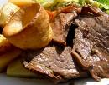
May 12 – Plain or BBQ Chicken Breast
- 5-7 pm

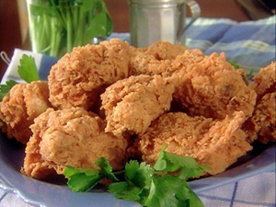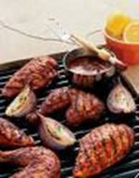

May 19 – Chicken Fried Streak – 5-7 pm

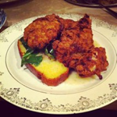

May 26 -- Rib Eye Steak– 5-7 pm

JUNE MEALS

Jun 2 – Plain or BBQ Ribs – 5-7 pm
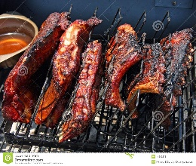
Jun 9 -- Roast Beef – 5-7 pm
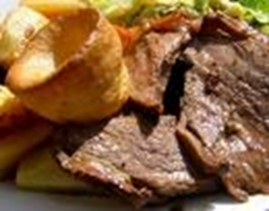
Jun 16 – Plain or BBW Pork Chop – 5-7 pm
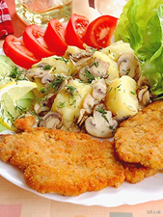
Jun 23 – Pulled BBQ Pork Sandwich
- Cheesy Potatoes, Coleslaw – 5-7 pm
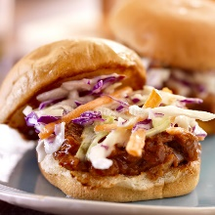
Jun 24 – Pancake Breakfast Auxiliary 8-Noon pancakes and sausage, orange juice, coffee, and milk
Free will Donation
Jun 30 – Ribeye Steak – 5-7 pm
May 27th Memorial Day Ceremonies
Ceremony at River Front --- am
Parade Line-Up --- 9:30 am
Parade --- 10:00 am to Oakwood Cemetery
The American Legion will host an Open House after the Ceremonies. Lunch will be at Noon.
Please Bring a Dish to Pass.
Meat will be Provided.
May 27th Memorial Day Ceremonies
Ceremony at River Front --- am
Parade Line-Up --- 9:30 am
Parade --- 10:00 am to Oakwood Cemetery
The American Legion will host an Open House after the Ceremonies. Lunch will be at Noon.
Please Bring a Dish to Pass.
Meat will be Provided.
May 27th Memorial Day Ceremonies
Ceremony at River Front --- am
Parade Line-Up --- 9:30 am
Parade --- 10:00 am to Oakwood Cemetery
The American Legion will host an Open House after the Ceremonies. Lunch will be at Noon.
Please Bring a Dish to Pass.
Meat will be Provided.

