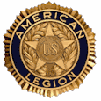
MEALS FOR
NOVEMBER - DECEMBER 2017
THE AMERICAN LEGION
DIXON POST 12
1120 West First Street, Dixon, Illinois 61021-2704
(815) 284-2003
________________________________________________________________________

NOVEMBER MEALS

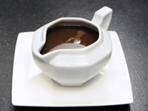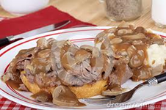
Nov 3 -- Roast Beef & Gravy Dinner
- 5:00-7:00 pm

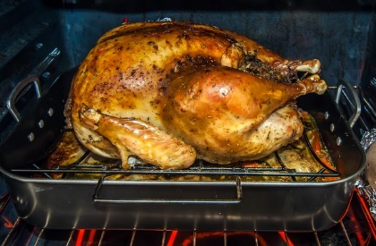
Nov 10 – Turkey Dinner with all the trimmings
- 5:00-7:00 pm

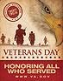
Nov 11 -- Open House after Veterans Day Ceremonies-- Lunch at Noon Bring dish to pass

Nov 17 – Cabbage Rolls Dinner -- 5:00-7:00 pm

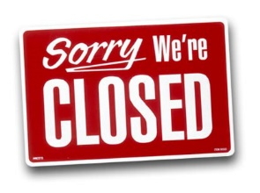
Nov 24 – NO MEAL

DECEMBER MEALS

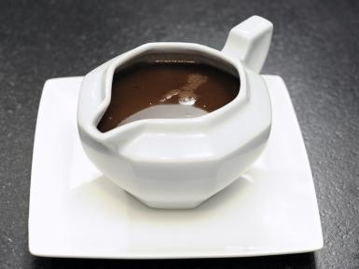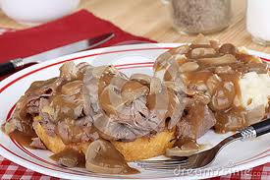
Dec 1 – Roast Beef and Gravy Dinner
- 5:00-7:00 pm

Dec 2 -- Post 12 Christmas Party
- 4:00 PM SOCIAL HOUR
- 5:00 PM DINNER

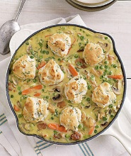
Dec 8 – Creamed Chicken & Biscuits
- 5:00-7:00 pm

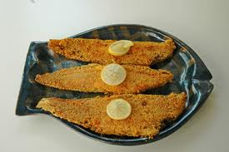
Dec 15 – Fish/Shrimp Dinner -- 5:00-7:00 pm
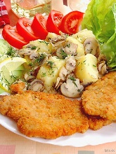
Dec 22 – Breaded Pork Chop Dinner
- 5:00-7:00 pm
Dec 29 – Steak Fry Dinner -- 5:00-7:00 pm

