**MEALS FOR**

**JANUARY - FEBRUARY 2017**

THE AMERICAN LEGION

DIXON POST 12

1120 West First Street, Dixon, Illinois 61021-2704

(815) 284-2003

**________________________________________________________________________**

**JANUARY MEALS**

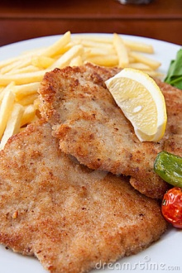

**Jan 6 -- Breaded Pork Chop -- 5:00-7:00 pm**

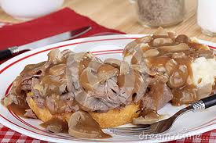

**Jan 13 -- Roast Beef & Gravy - 5:00-7:00 pm**

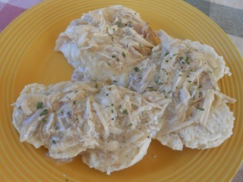

**Jan 20 -- Creamed Chicken & Biscuit**

* **5:00-7:00 pm**

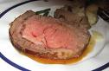 

**Jan 27-- Prime Rib/Shrimp -- 5:00-7:00 pm**

**FEBRUARY MEALS**

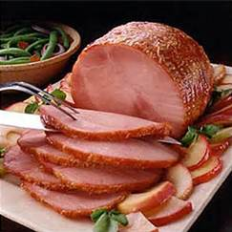

**Feb 3 -- Ham Dinner -- 5:00-7:00 pm**

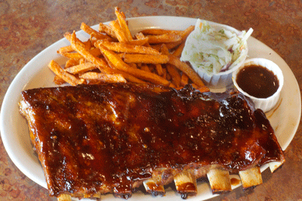

**Feb 10 -- BBQ Ribs Dinner -- 5:00-7:00 pm**



**Feb 17 -- Roast Beef Dinner 5:00-7:00 pm**

**Steak 3.wmf**

**Feb 24 -- Steak Dinner -- 5:00-7:00 pm**