**MEALS FOR**

**MARCH - APRIL 2017**

THE AMERICAN LEGION

DIXON POST 12

1120 West First Street, Dixon, Illinois 61021-2704

(815) 284-2003

**________________________________________________________________________**

**MARCH MEALS**

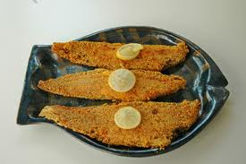

**Mar 3 -- Fish Dinner** **-- 5:00-7:00 pm**

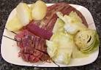

**Mar 10-- Corned Beef & Cabbage --**

* **5:00-7:00 pm**

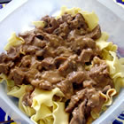

**Mar 17 -- Fish / Beef & Noodles**

* **5:00-7:00 pm**

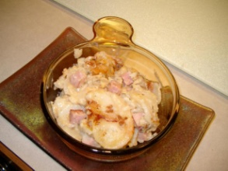

**Mar 24 -- Fish/Au gratin Potatoes & Ham**

* **5:00-7:00 pm**

**Steak 3.wmf**

**Mar 31-- Shrimp/Steak -- 5:00-7:00 pm**

**APRIL MEALS**



**Apr 7 -- Fish/Shrimp Dinner -- 5:00-7:00 pm**

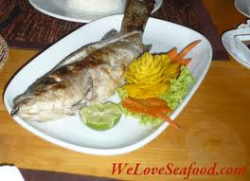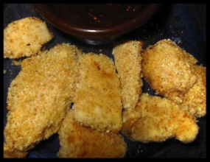

**Apr 14 -- Fish/Chicken Strips Dinner**

* **5:00-7:00 pm**

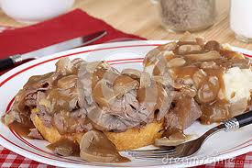

**Apr 21 --** **Roast Beef Dinner 5:00-7:00 pm**

**Steak 3.wmf**

**Apr 28 -- Steak Dinner -- 5:00-7:00 pm**