**MEALS FOR**

**MAY - June 2017**

THE AMERICAN LEGION

DIXON POST 12

1120 West First Street, Dixon, Illinois 61021-2704

(815) 284-2003

**________________________________________________________________________**

**MAY MEALS**

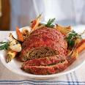

**May5 -- Meatloaf Dinner -- 5:00-7:00 pm**

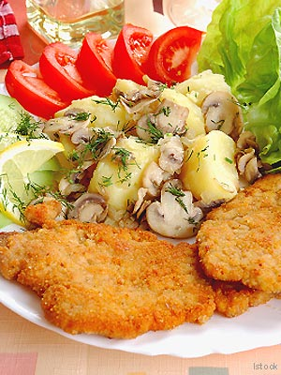

**May 12 -- Breaded Pork Chop Dinner**

**5:00-7:00 pm**

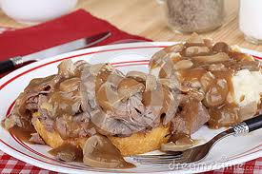

**May 19 -- Roast Beef & Gravy Dinner**

**5:00-7:00 pm**

**Steak 3.wmf**

**May 26 – Steak Dinner -- 5:00-7:00 pm**

**JUNE MEALS**

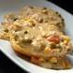

**Jun 2 – Chicken & Biscuits Dinner**

**5:00-7:00 pm**

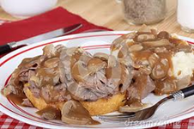

**Jun 9 – Roast Beef & Gravy Dinner**

**5:00-7:00 pm**

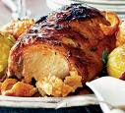

**Jun 16 – Roast Pork Dinner 5:00-7:00 pm**

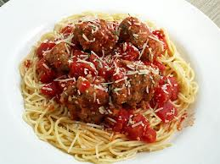

**Jun 23 – Spaghetti & Meatballs Dinner**

**7:00 pm**



**Jun 30 -- Steak Dinner -- 5:00-7:00 pm**