**MEALS FOR**

**SEPTEMBER - OCTOBER 2017**

THE AMERICAN LEGION

DIXON POST 12

1120 West First Street, Dixon, Illinois 61021-2704

(815) 284-2003

**________________________________________________________________________**

**SEPTEMBER MEALS**

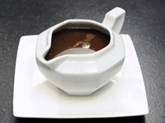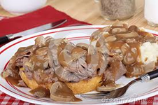

**Sep 1 -- Roast Beef & Gravy Dinner**

* **5:00-7:00 pm**



**Sep 8 –** **Creamed Chicken & Biscuits Dinner**

* **5:00-7:00 pm**

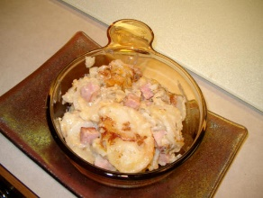

**Sep 15 – Ham & Au gratin Potatoes Dinner**

* **5:00-7:00 pm**

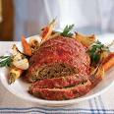

**Sep 22 – Meat Loaf Dinner -- 5:00-7:00 pm**

**Steak 3.wmf**

**Sep 29 – Steak Fry Dinner** **-- 5:00-7:00 pm**

**OCTOBER MEALS**

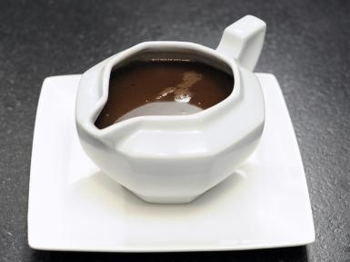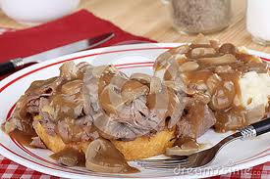

**Oct 6 – Roast Beef and Gravy Dinner**

* **5:00-7:00 pm**

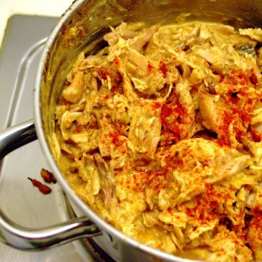

**Oct 13 – Creamed Chicken Hungarian Style**

* **5:00-7:00 pm**

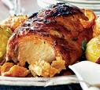

**Oct 20 – Pork** **Roast Dinner 5:00-7:00 pm**



**Oct 27 – Steak Fry Dinner** -- **5:00-7:00 pm**