MEALS FOR
MAY JUNE 2018
THE AMERICAN LEGION
DIXON POST 12
1120 West First Street, Dixon, Illinois 61021-2704
(815) 284-2003
________________________________________________________________________

MAY MEALS

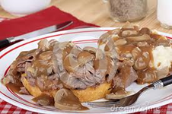

May 4 – Roast Beef, Mashed Potatoes &
Gravy -- 5:00-7:00 pm

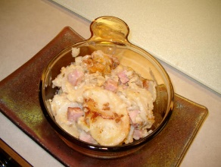

May 11 – Ham and Augratin Potatoes
- 5:00-7:00 pm

May 18 – Creamed Chicken & Biscuits
- 5:00-7:00 pm

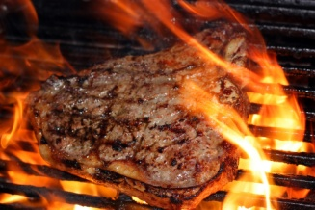

May 25 – Steak Fry Dinner

JUNE MEALS

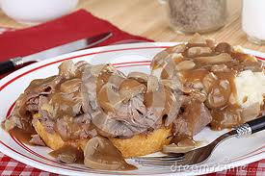

June 1 – Roast Beef, Mashed Potatoes &
Gravy -- 5:00-7:00 pm

June 8 – No Meal (Private Party)

June 15 – Fish Dinner
- 5:00-7:00 pm

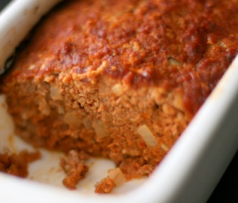

June 22 – Meat Loaf Dinner -- 5:00-7:00 pm

June 29 – Steak Fry Dinner & Bake Sale
- 5:00-7:00 pm

