MEALS FOR
JULY AUGUST 2018
THE AMERICAN LEGION
DIXON POST 12
1120 West First Street, Dixon, Illinois 61021-2704
(815) 284-2003
________________________________________________________________________

JULY MEALS

July 6 -- NO MEAL

July 13 – Creamed Chicken & Biscuits
- 5:00-7:00 pm

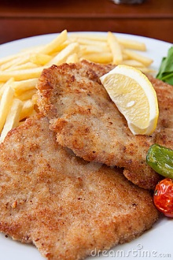

July 20 -– Breaded Pork Chop Dinner
- ● 5:00-7:00 pm

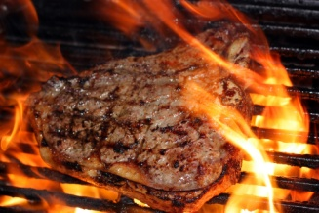

July 27 – Steak Fry Dinner
- 5:00-7:00 pm

AUGUST MEALS

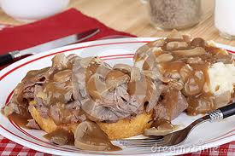

August 3 – Roast Beef & Gravy
- 5:00-7:00 pm

August 10 – Ham and Augratin Potatoes
- 5:00-7:00 pm

Aug 17 - Creamed Chicken & Biscuits
- ● 5:00-7:00 pm

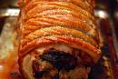
August 24 – Roast Pork Dinner
- 5:00-7:00 pm

June 29 – Steak Fry Dinner & Bake Sale
- 5:00-7:00 pm

